Normal Operating
Procedure

Contents

- Saltdean Swim & Club (SSSC) Normal Operating Procedure (NOP)
- Description
- Coach Requirements
- Medical, Swim and fitness requirements
- Age requirements
- Risk assessment
- Registers
- Emergency Action Plan (EAP)
- Ratios
- Coach/Qualified Persons Qualifications Matrix
- Checking PPE & Safety Equipment
- Coach and safety cover PPE & Safety Equipment
- Participant PPE & Equipment

- Buddy System - TBC
- Pre-departure communications, late back and overdue
- Feedback, debrief and lessons learnt
- Awards & Qualifications
- Coach pre-season safety brief and acknowledgement of documentation

Saltdean Swim & Surf Clubs (SSSC) Normal Operating Procedure (NOP)
This document should be read in conjunction with the most current SLSGB National Safety Guide Training and Coaching guide, SSSC’s Local Operating Procedure (LOP) and Saltdean SSSC’s Emergency Action Plan (EAP).

Description

Surf lifesaving is a multi-disciplined activity with the aims of training and educating participants from the age of eight years with the skills to save a life on the beach and in the ocean. Participants often join to compete in surf lifesaving competition, which are predominantly the disciplines of beach running, surf swimming, paddle boarding and surf skiing, both of short and long distance. Activities generally take place on a beach and in the ocean, but sessions can be run in a swimming pool during the winter months. Due to the activity being undertaken in the surf zone or open ocean, comprehensive safety measures must be in place in order to prevent an incident or deal with one should it occur.

Coach Requirements

Coaches for Saltdean Swim and Surf Club as a minimum required to hold a current recognised SLSGB Tube and/or Board Rescue Lifesaving Award, SLSGB or recognised First Aid Award and hold a competence award for the discipline being coached.

All coaches will be familiar with the Saltdean Swim and Surf Club Child Protection Policy/Safeguarding Policy and will be DBS checked.

All coaches will be familiar with the SLSGB National Safety Guide Training and Coaching guide and SSSC’s Safety Policy & Risk Assessment, LOP, NOP and EAP.

Coaches will be punctual and wear appropriate colour rash vests denoting their roles whilst coaching sessions on the beach.

Coaches are responsible for the safety of the participants, alongside the day’s nominated water safety team and beach lifeguard.

Medical, Swim and fitness requirements

Participants must be able to swim 50m unaided confidently and be able to tread water for 3 minutes.

Participants may attend three trial sessions consultatively but thereafter are required to complete a membership application in order to be a full member of Saltdean SSC with SLSGB insurance.

Coaches must be aware of the swimming ability, general fitness, and water confidence of the participants prior to proceeding with surf lifesaving activities; any concerns will be raised with the participant privately.

Participants must be in good health and good physical condition to take part, free from any injuries and or medical conditions that would endanger them, the coach or any other individual. The coach must be made aware of any participant’s medical conditions and the trainee will be required to keep any necessary medication available at water’s edge during the activity.

If the coach has any doubts regarding a participant's ability to complete the intended training safely they should discuss these with the safety officer before starting the training session.

Age requirements

A minimum age of 8 years is required for surf lifesaving activities.

Clubs Activity Safety Plan/Analytical Risk assessment

The Level 2 coach (if competent ) or another competent person e.g., lifeguard familiar with the beach/location being used, the LOP and the EAP will complete a club activity safety plan along with the Analytical Risk Assessment (ARA) for the session. They will then brief the coaches on the conditions and any mitigation that has been identified during the completion of the ARA. This may result in a need to modify intended training to take account of the prevailing conditions.

Coaches should brief participants on any risks identified on the day together with any specific instructions to mitigate them, at the start of their session.

Coaches must maintain an awareness of changing conditions and keep the findings of the ARA under review throughout the session. If changing conditions affect the safety of the session, they must perform a dynamic risk assessment and implement any necessary mitigation immediately. This should then be added to the ARA for the session.

Following the session, the ARA needs to be uploaded to the clubs G Drive ARA Folder and renamed with the date as follows Year/Month/Day - 20241001
This will need to be done by a club trustee.

Registers

A register of attendance must be taken prior to all training sessions by the beach side coordinator.
Any changes e.g., different parent/carer regarding collection/pick up of nippers must also be noted if provided by the parent/carer.
Nippers must not be allowed to leave alone without the consent in writing from their parent/carer.

It is the level 2 coach’s responsibility to monitor the number of participants throughout the session to ensure all are present and accounted for, at all times, until the participants leave the beach.

The number of participants must also be entered by the Level 2 coach onto the session’s ARA along with the names of all coaches and safety cover involved in the session.

Emergency Action Plan (EAP)

The Saltdean Swim and Surf Club (SSSC) Emergency Action Plan details the actions to be taken in the event of procedure should an emergency occur during the activity, it is essential that all coaches, safety cover and club officers are aware of this plan.

Ratios

The following table below is provided by the SLSGB (this can also be found within the National Safety Guide For Coaching and Training) and indicates the ratios for the number of trainees per trainer or coach for training, coaching, examination, sessions in open water environment.

Please note this is only a guide to be used as a starting point and will vary in accordance with the ARA and DRA for each session.

The ratios advised assume that all safety cover as determined by the ARA and DRA is provided.

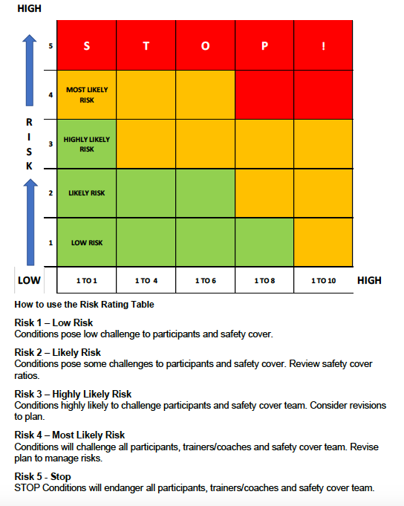

Coach/Qualified Persons Qualifications Matrix

Role | Minimum essential qualifications
Safety cover | DBS checked if over 18  SLSGB full member over 16 years old  Surf Coach Rescue or Tube Rescue and Board Rescue and First Aid.
Coach | As above and:  SLSGB Level 1 coach
Lead coach | As above and:  SLSGB Level 2 coach

Checking PPE & Safety Equipment

All PPE and Equipment should be checked at the point of issue for any defects. It is a coach’s
responsibility to ensure that the participant has suitable PPE for the sea and weather conditions and highlight any damage or poor fit.

The responsible Level 2 coach will examine all club equipment required for a training session before the session starts, ensuring it is fit for use. At the end of the session, they will again
examine the equipment for damage and ensure that it has been cleaned and made safe for storage, before putting it away.

Damaged equipment must be reported to the coaches so that it can be recorded, checked and repaired.

Coach and safety cover PPE & Safety Equipment

- Blue rash vest if Coach, Red vest if water Safety Cover, Green vest if club water safety cover or under 16yo Water safety Cover. Long sleeved red vest for Lifeguard
- Wetsuit or suitable wet gear for temperature and sea conditions
- Whistle
- Rescue board or tube according to the condition
- Mobile phone and/or Handheld VHF radio
- First Aid kit & Pocket Mask
- Dry Bag, including any medication
- Specific safety equipment required for ski, IRB etc. as appropriate

Participant PPE & Equipment

- Yellow rash vest
- Wetsuit or suitable wet gear for temperature and sea conditions
- Boots or fins (seasonal)
- Club Cap
- Goggles

Pre-departure communications, late back and overdue

Before setting out on an open water session the coach should communicate
with the water safety team for raising the alarm if they believe the group is overdue.

Pre-departure the following information should be communicated:
- Number of participants/coaches/total number
- Time and place of departure/arrival
- Route to be taken
- Is a radio/mobile phone being carried
- Name of coach
- Vehicle details (make & registration) if appropriate

Feedback, debrief and lessons learnt

There should be an opportunity for each participant to feedback his or her thoughts
on the session in a discreet way.

Coaches should be able to feedback and review the session and have the
opportunity to learn from sessions and deal with any specific issues.

Awards & Qualifications

A participant on joining the club will be give the necessary training in order to obtain a
Competence/Skills Award/National Surf Safety Award following the guidance provided by SLSGB. It is essential that a surf competence/skill award is completed before training can be started on the surf craft i.e. paddleboard, surf ski and IRB.

Coach pre-season safety brief and acknowledgement of documentation

It is a requirement of SSSC for coaches to attend safety and safeguarding meetings and acknowledge they have read and understand the club policies and procedures.

