Local Operating
Procedure

Contents

- Foreword
- Coaching and Safety Team Signature Sheet
- Location Details
- Overview of Typical Beach and Sea Conditions
- Estimated Beach and Water Usage
- Training
- Dates
- Attendance
- Club Equipment
- Session Schedule
- Communications
- Type of session

Foreword

The procedures set out in this document are established as a guide to assist SLSGB accredited clubs
in maintaining a safe environment and should be followed accordingly. This is not a standalone
document and should be read in conjunction with the most current SLSGB National Safety Guide
Training and Coaching guide, SSSC’s Normal Operating Procedures (NOP), SSSC’s Emergency
Action Plan (EAP) and any relevant event safety information. Additionally, refer to government and
local level legislation and any other relevant documentation to aid safety, including all relevant
Government and SLSGB guidance regarding the COVID-19 in place at the time.

Coaching and Safety Team Signature Sheet

Signature sheet for recognition of Local Operating Procedures at Saltdean Swim and Surf Club for
the year 2026.

I have read and understood the following Local Operating Procedures and understand it is my duty
to follow the procedures and other relevant documentation, including the current SLSGB National
Safety Guide Training and Coaching guide, SSSC’s Normal Operating Procedures (NOP), SSSC’s
Emergency Action Plan (EAP) and SSSC’s Generic Risk Assessment:

Role | Full Name | Email and mobile number | Signature | Date
Chair | Matthew Coyne
Vice Chair | Richard Valder-Davis
Safeguarding Officer | Richard Valder-Davis
Health & Safety Officer | Graeme Forrest
Training Officer | Kevin Pope
Training Assessor | Kevin Pope
Volunteer Coordinated | TBC
Competitions  Officer | Graeme Forrest
Nipper Captain | Matthew Coyne
Junior Captain | Richard Valder-Davis
Senior Captain | TBC
Lifeguard Inc. First Aid | Chris Mellett / Finn McCarthy
Lifeguard Inc. First Aid | Graeme Forrest
Lifeguard Inc. First Aid | Kevin Pope / Richard Valder-Davies
Level 2 coach | Kevin Pope
Level 2 coach | Matthew Coyne
Level 2 coach | Richard Valder-Davies
Level 2 coach | Graeme Forrest
Level 2 coach
Level 2 coach | Ollie Armfield
Level 2 coach | Matthew Vermeer
Level 2 coach | David Collins
Level 1 coach | Rose Miller
Level 1 coach
Safety Team | Rose Miller
Safety Team | Richard Valder-Davies
Safety Team | Rachael Curtis
Safety Team | David Collins
Safety Team | Matthew Coyne
Safety Team | Matthew Plank
Safety Team | Catherine Sykes
Safety Team | Chris West
Safety Team | Jon Tilley
Safety Team | Matt Vemeer
Safety Team | Mike Harvey
Safety Team | Ollie Armfield
Safety Team | Ryan Vermeer
Safety Team | Rachael Perry
Safety Team | Saul Woods
Safety Team | Verity Hudson
Safety Team | Steve Morgenhalter
Safety Team | Tamara Tompsett
Safety Team | Sean Forrest
Safety Team | Suzie Sturgeon
Safety Team | Mirran Daykin
Safety Team | Sarah Gilfeather
Safety Team | Lara Williams
Safety Team | Gareth Thomas

Location Details

The Sea Training Sessions will be conducted on Saltdean Beach, in front of the White Cliffs Café between the stone groynes. However, some sessions may be further afield depending on the session plan and the outcome of the ARA.

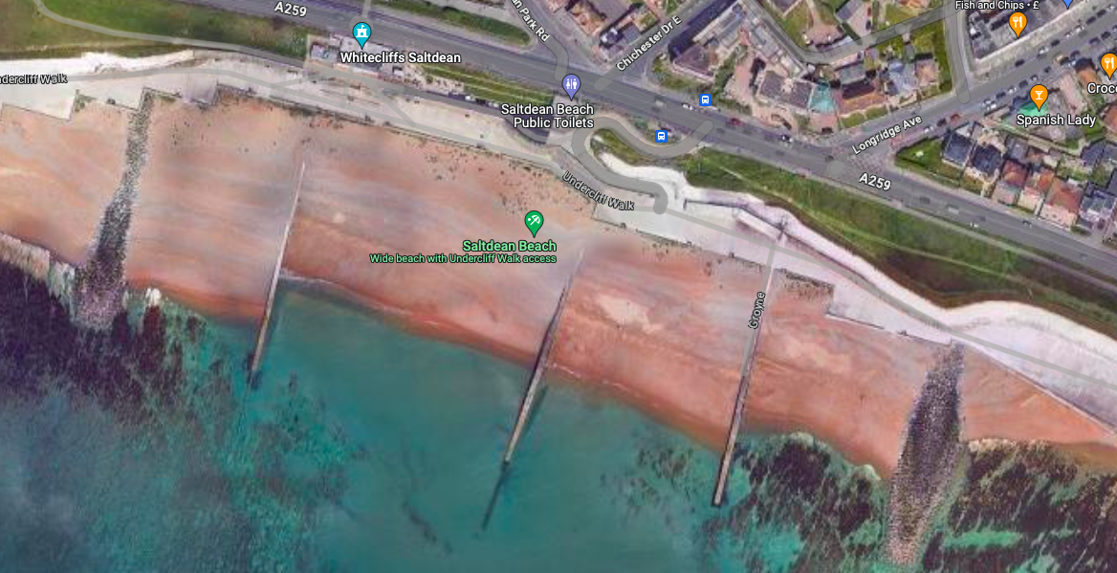

Saltdean Beach is located in Brighton, East Sussex. Saltdean's beach is a shingle beach at high tide
with a flat, sandy foreshore at low water. The shingle high water mark can be very steep, creating a
significant shore dump.

The seafront has a cafe, toilets and an undercliff walk access that can be very busy, especially in fine weather.

Overview of Typical Beach and Sea Conditions

The beach conditions are typically of a sloping shingle bank, with a level area of sand, rocks and reef exposed or covered with shallow water at low tide. The rocks and reef are located mainly to the right hand side of the beach which are visible at low tide, and covered at high tide.
At high tide the sea slopes off quickly meaning swimmers can be out of their depth as little as a metre offshore. Due to the shingle structure the shape of the beach can change from one day to the next.

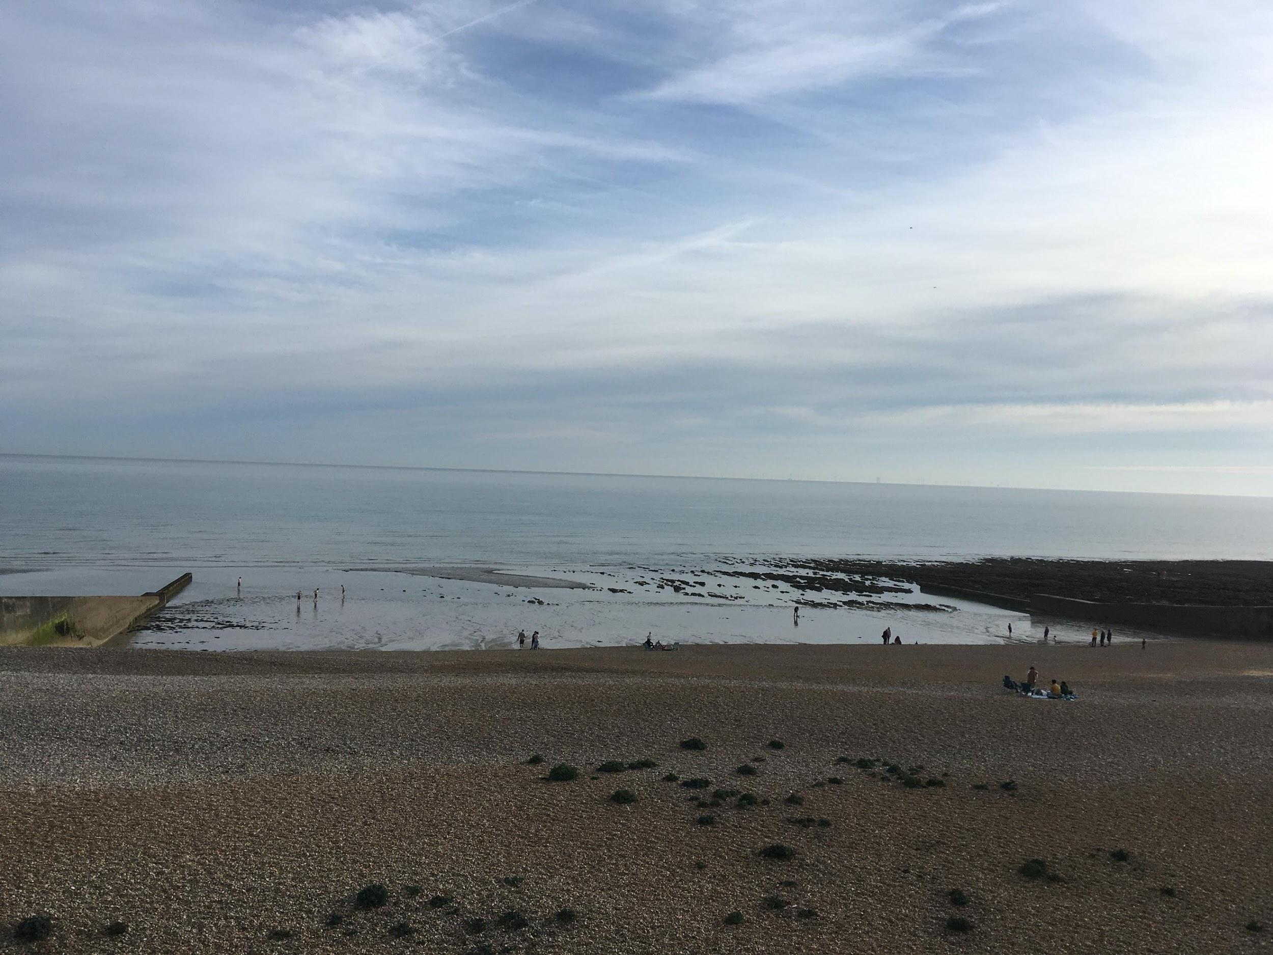

The sea conditions are typically influenced by tide and prevailing wind. The most common conditions
are south westerly wind and swell with a consequent shore dump at high tide. Northerly winds are
offshore and will typically flatten the waves close to the shore, but conditions can still be deceptively
choppy.

Always remember to check tide tables (available online or from the Seafront Office) so that you are
aware of when the next high tide is and the likely currents. The rising tide flows from west to east.
About 90 minutes before high tide, the flow reverses and runs east to west until about an hour
before low tide. However, the current is affected by the wind, increasing, delaying or cancelling it
depending on direction and strength of tide and wind.

Be aware that in strong north easterly winds, a strong easterly current can build close to shore. This
presents a particular danger from the training beach as it will take swimmers and boards or other
craft quickly towards the groyne, and reef found just the other side.

At low tides you should be aware that rocks/reefs can be invisible below the surface. Elsewhere
on the beach damaged groynes can sometimes leave concrete blocks on the beach. As these are not
removed promptly it is best to keep at least 10 metres from any groyne at low tide.

Remember that conditions will vary as the beach and sea are open environments that are
continuously changing.

Estimated Beach and Water Usage

In the summer, there can be many hundreds of beach users and up to 100 water users between the
groynes, at peak times. However, in normal club operating hours there are far fewer, typically
around 10 beach and 5 water users.

Brighton council provide lifeguards on Saltdean beach between the end of July and the 1st week of
September. The areas that are patrolled by lifeguards are signalled by flags on the beach and buoys,
showing the swimming areas, in the sea.

Two flags are flown independently to signal the presence of a lifeguard
- Red and yellow flags are raised on patrolled beaches to show safe swimming conditions
- Red flags indicate that conditions are considered unsafe for sea swimming
- Orange flags indicate an offshore wind, making conditions unsafe for inflatables
- Chequered flags for surf craft areas, ensuring SUP’s stay clear of the primary swim beaches.

Swimmers should not venture further from shore than the line of yellow buoys as this indicates the
limit from the shore that power boats are permitted.

Training

Location for sea training

All sea sessions take place on the beach in front of the White Cliffs Cafe.

Session coaches/volunteers will be permitted access to enable equipment to be safely removed and to ensure first aid equipment is available.
The meeting point for sessions is on the beach, in front of the undercliff tunnel.

Pool sessions held at the Saltdean Lido are held under the risk assessments of Wave (Saltdean Lido Lifeguards). All SSSC members must abide by and be directed by these responsible organisations and their requirements during these sessions. The number is limited according to the capacity and the number of Fusion Lifeguards attending.

Dates

Sea Side - May 2026 to Oct 26
Pool Side - June for 13 x weeks

Attendance

All participants, trainers and safety cover will need to arrive ready to begin on the beach, wearing
wetsuits, gloves, hoods etc. and carrying goggles, fins and any other personal equipment they may
need such as a bottle of water (no single use of plastics!). Limit any other personal belonging as there
will be no secure storage available. No personal equipment may be lent to or used by another
member of the session during the session.

Club equipment

Each member will be assigned their club equipment during the session and it is their responsibility to look after this equipment during the nipper sessions. Any damage caused to the equipment must be reported immediately.

At the end of the session, the Level 2 coach will ensure that the equipment is cleaned and made
safe, prior to it being returned to storage.

Session Schedule

Sessions are held during the warmer months of the year (May to September), however this may extend over the winter months. The groups are split according to age and ability and are strictly limited on numbers.

Nippers (age 8 to 12):
Juniors/Youth (age 12 (if turning 13 within that year)/13 to 15):
Adults/Masters (age 16+):

Saturday sea session between 08:30-11:00 up to 40 participants per age group, 8-10 facilitators

Friday Pool session 18:00-19:00

Communications

Communications between shore and club members in or on the water will be done using standard
SLSGB hand signals.

When IRB’s (Inshore Rescue Boat) are in use VHF radios will be used and the working channel will be selected and tested
prior to launch. As a minimum each IRB is to carry a VHF and the Level 2 coach will also carry a VHF.

Type of session

The type of session planned will vary based on the outcome of the Analytical Risk Assessment (ARA),
training requirement, the competence of those being trained, the environmental conditions on the
day and the current COVID-19 (C19) restrictions and guidance in place (if applicable).

They will typically include general fitness, first aid, board paddling, sea/surf swimming, rescue tube
work, IRB, Surf Skis and lifesaving skills.

As an organisation that has its roots in saving lives on the beaches, safety is paramount. If the
planned session cannot be safely maintained to meet the environment (weather, numbers etc.) the session will either be altered to one that can or be cancelled.

